Chapter 7, Solution 60.

Let I be the inductor current.
For t < 0, 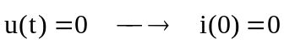
For t > 0,  